**Rcmdr**: A simple yet powerful menu driven GUI package for statistical analysis in R/Rstudio.

**Installation: Windows**

**Rcmdr** package has been in development since 2005 and this tutorial uses RStudio (version 0.99.893) as its workspace where the base R version used is 3.1.2 ("Pumpkin Helmet").

RStudio package installation can be done by command line or using the “Install packages tab” as shown below. There are many other useful plugins which can be used within Rcmdr. This makes it a very powerful statistical analysis tool.

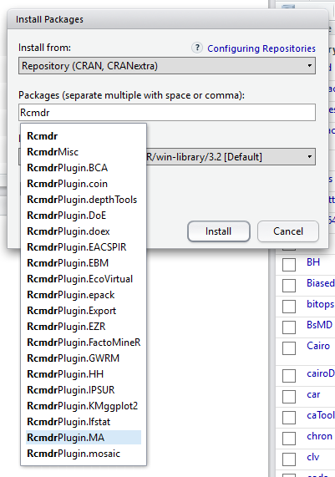

Rcmdr can be summoned by using command line

# library(Rcmdr) or simply by selecting the package from the available packages in the R directory.

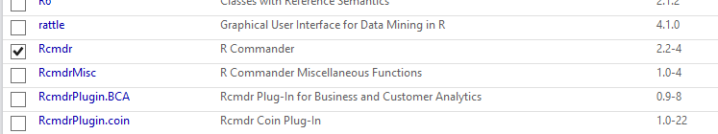

Loading “Rcmdr” package identifies the packages required for its proper functioning and gives the option to install them. Once the R base directory is complete for its running, the following message can be seen

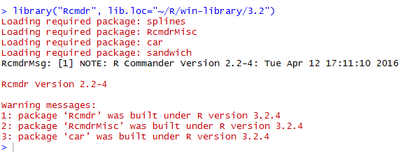

This opens a separate window for Rcmdr which is ready for use.

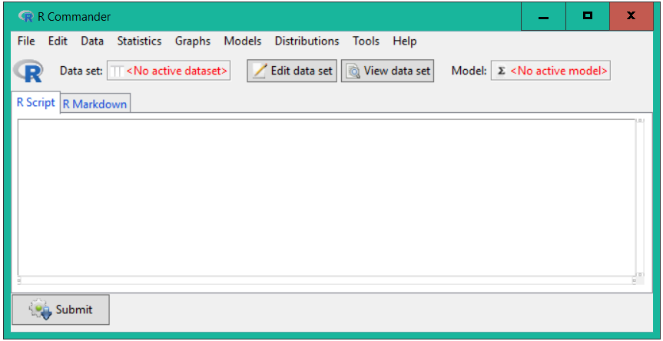

**Installation: Linux**

I have tested installation of RStudio and Rcmdr in various distributions of Linux. The recent releases of Ubuntu 15/16 works good with this but some of the listed distributions have shown incompatibility in loading Rcmdr due to some backport connection issues which directly connects to the R base update engine. In any of the above cases the user should be identified as the root/superuser.

Ubuntu- Works good

CentOs- No

Elementary OS- No

Peppermint- No

Debian 3.8- No

ChromeLinux- No

SliTaz- No

Bunsenlab- No

**Installation- Mac Os**

Installation on a Mac is troublesome. Only refer experienced user installation instructions. Moving files from one or other directory can damage important core processes required for proper running of the base software.

**Importing data:**

One of the most important advantages of using Rcmdr is that it identifies various formats of data files. Again, Rcmdr would prompt if new packages are required for reading such datasets.

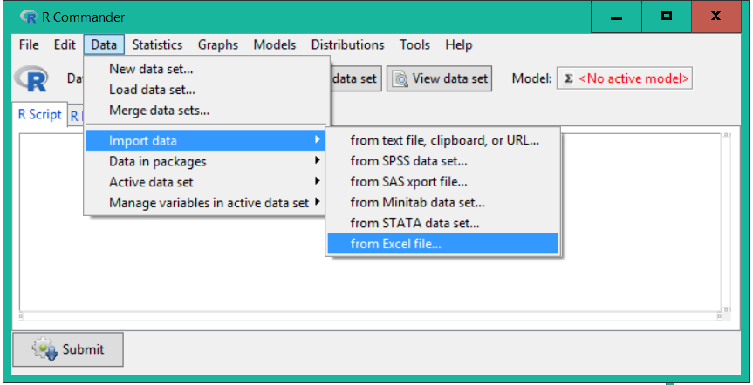

Rcmdr also makes it very easy to access the inbuilt dataset which come with Rbase. This is a great way for introducing dataset for analysis in classroom settings.

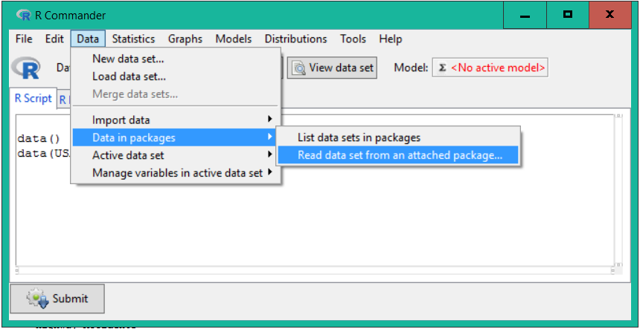 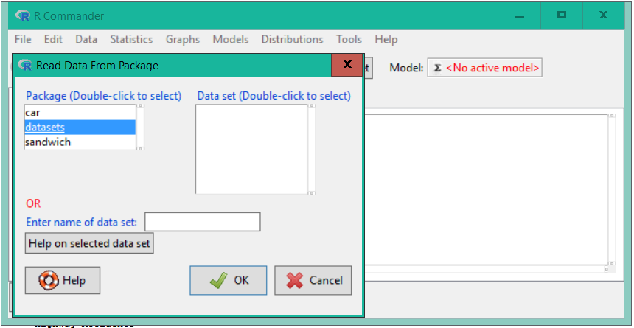

**Example 1:**

Using data for “airquality”

*Script

# data(airquality, package="datasets")

This data talks about Newark Air Quality Measurements. If we wanted to create a scatterplot matrix of the few variables, it can be easily done in Rcmdr by using the following settings.

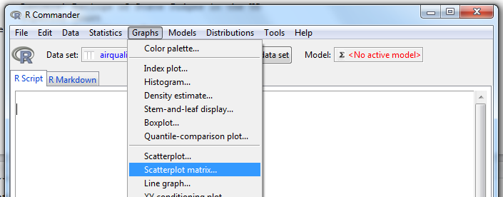 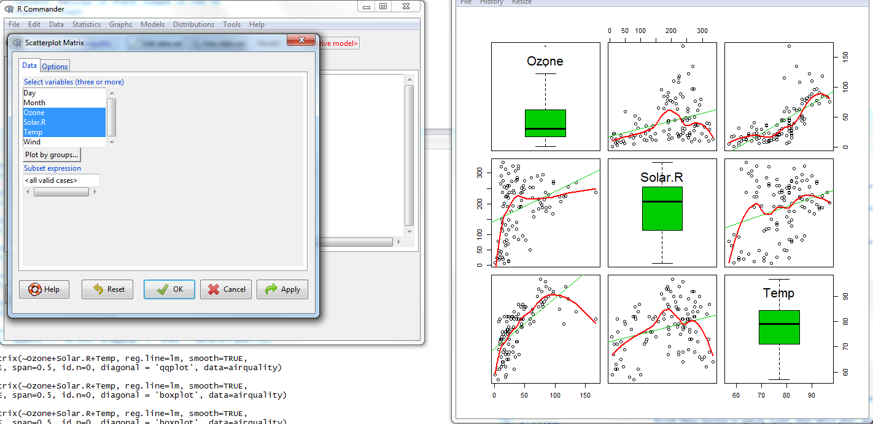

Script for generating this scatterplot matrix.

#scatterplotMatrix(~Ozone+Solar.R+Temp, reg.line=lm, smooth=TRUE,

spread=FALSE, span=0.5, id.n=0, diagonal = 'boxplot', data=airquality)

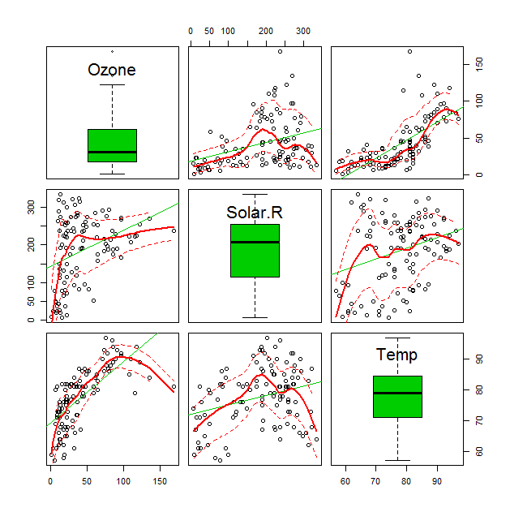

**Preparing XY conditioning plot with Rcmdr**

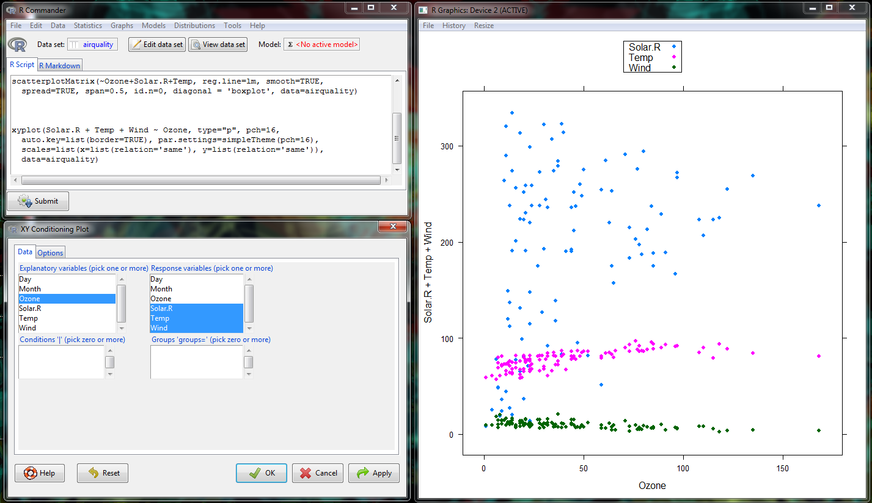

This can also be presented in different panels by checking the options tab: 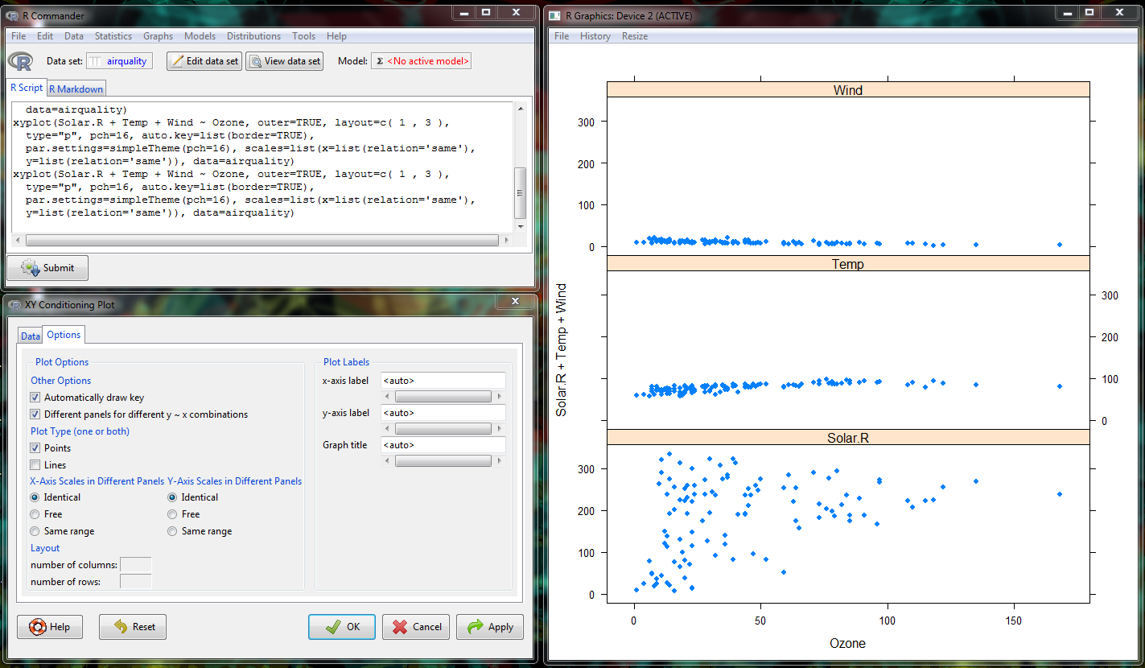

**3D scatter plot:**

#script

scatter3d(Ozone~Solar.R+Temp, data=airquality, fit=c("linear","smooth"),

bg="white", axis.scales=TRUE, grid=TRUE, ellipsoid=FALSE)

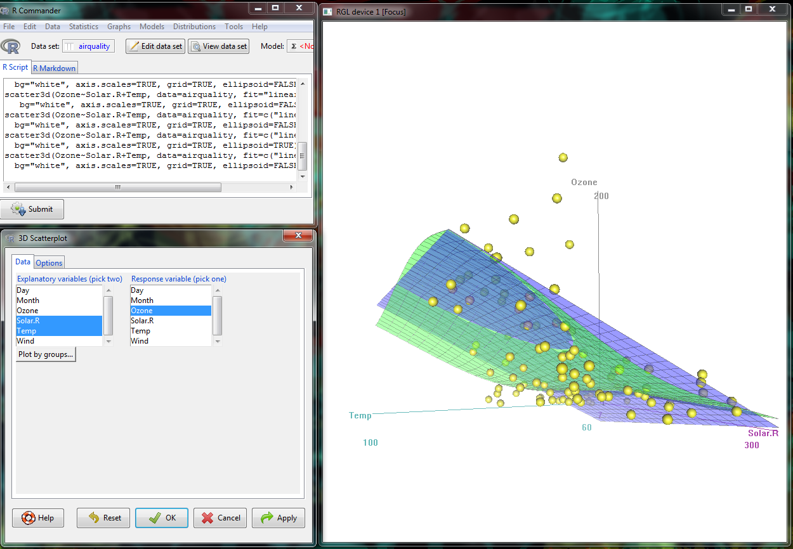

**Using Plugins in Rcmdr**

There are several useful plugins included in Rcmdr. These plugins are very useful under certain needs such as RcmdrPlugin.EZR is especially designed for medical data analysis. Likewise RcmdrPlugin.KMggplot2 is known for improving graphing capabilities. The picture below shows many other plugins, the functions of those can be explored under RStudio help window.



**Using RcmdrPlugin.EZR in Rcmdr**

A modified version of the class data has been used here for demonstration.

The data can be downloaded from here <https://www.dropbox.com/s/9ps2zjk5x773977/SimDataTrend.csv?dl=0>

Scatter plot for day(x) and biomass(y)

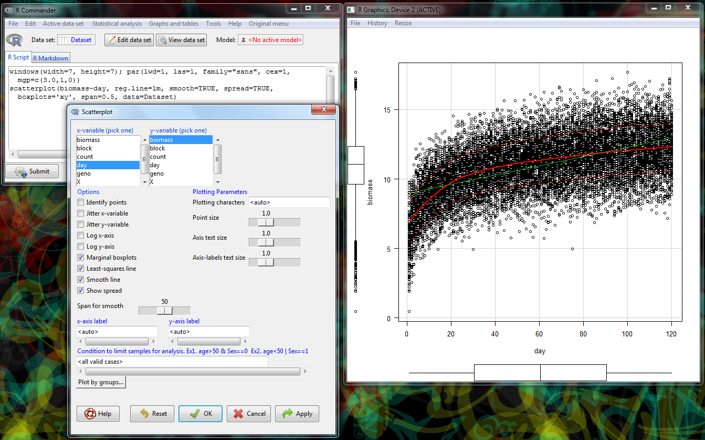

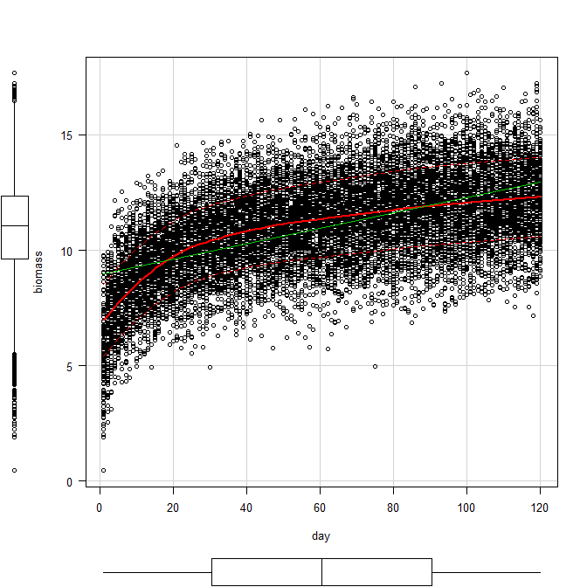

**Performing simple statistical analysis in Rcmdr: 1 way ANOVA**

The data used in this analysis can be downloaded from here.

<https://www.dropbox.com/s/o2t34qf1a4inbpk/Exp2.csv?dl=0>

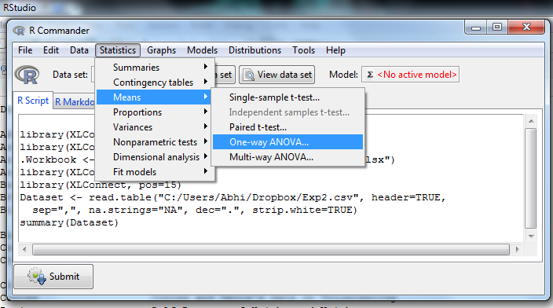

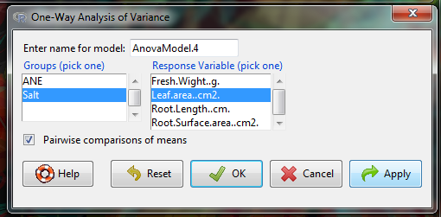

**A general output of this would provide details about the analysis.**

Rcmdr> AnovaModel.5 <- aov(Leaf.area..cm2. ~ Salt, data=Dataset)

Rcmdr> summary(AnovaModel.5)

Df Sum Sq Mean Sq F value Pr(>F)

Salt 2 21819 10910 37.26 1.06e-10 ***

Residuals 51 14931 293

---

Signif. codes: 0 '***' 0.001 '**' 0.01 '*' 0.05 '.' 0.1 ' ' 1

Rcmdr> with(Dataset, numSummary(Leaf.area..cm2., groups=Salt, statistics=c("mean",

Rcmdr+ "sd")))

mean sd data:n

0mM Salt 144.60809 13.82020 18

100mM Salt 116.48829 17.31248 18

200mM Salt 95.54478 19.68726 18

Rcmdr> local({

Rcmdr+ .Pairs <- glht(AnovaModel.5, linfct = mcp(Salt = "Tukey"))

Rcmdr+ print(summary(.Pairs)) # pairwise tests

Rcmdr+ print(confint(.Pairs)) # confidence intervals

Rcmdr+ print(cld(.Pairs)) # compact letter display

Rcmdr+ old.oma <- par(oma=c(0,5,0,0))

Rcmdr+ plot(confint(.Pairs))

Rcmdr+ par(old.oma)

Rcmdr+ })

Simultaneous Tests for General Linear Hypotheses

Multiple Comparisons of Means: Tukey Contrasts

Fit: aov(formula = Leaf.area..cm2. ~ Salt, data = Dataset)

Linear Hypotheses:

Estimate Std. Error t value Pr(>|t|)

100mM Salt - 0mM Salt == 0 -28.120 5.704 -4.930 < 1e-04 ***

200mM Salt - 0mM Salt == 0 -49.063 5.704 -8.602 < 1e-04 ***

200mM Salt - 100mM Salt == 0 -20.944 5.704 -3.672 0.00156 **

---

Signif. codes: 0 '***' 0.001 '**' 0.01 '*' 0.05 '.' 0.1 ' ' 1

(Adjusted p values reported -- single-step method)

Simultaneous Confidence Intervals

Multiple Comparisons of Means: Tukey Contrasts

Fit: aov(formula = Leaf.area..cm2. ~ Salt, data = Dataset)

Quantile = 2.4143

95% family-wise confidence level

Linear Hypotheses:

Estimate lwr upr

100mM Salt - 0mM Salt == 0 -28.1198 -41.8897 -14.3499

200mM Salt - 0mM Salt == 0 -49.0633 -62.8332 -35.2934

200mM Salt - 100mM Salt == 0 -20.9435 -34.7135 -7.1736

0mM Salt 100mM Salt 200mM Salt

"c" "b" "a"

I have little to very simple statistical analysis involved in my research. The data used in this tutorial are the one which come inbuilt with R or the one used in our class session. The third dataset used for ANOVA was from my previous research. All these can be downloaded for few days from the link provided in the page.

**References:**

Fox J (2005). “The R Commander: A Basic-Statistics Graphical User Interface to R.” Journal of Statistical Software, 14(9), 1–42. URL <http://www.jstatsoft.org/v14/i09/>